 |  | 
Hi3516A/Hi3516D Hardware Design
Checklist

Issue | 04
Date | 2016-10-28

Copyright © HiSilicon Technologies Co., Ltd. 2014-2016. All rights reserved.
No part of this document may be reproduced or transmitted in any form or by any means without prior written consent of HiSilicon Technologies Co., Ltd.

Trademarks and Permissions
, , and other HiSilicon icons are trademarks of HiSilicon Technologies Co., Ltd.
All other trademarks and trade names mentioned in this document are the property of their respective holders.

Notice
The purchased products, services and features are stipulated by the contract made between HiSilicon and the customer. All or part of the products, services and features described in this document may not be within the purchase scope or the usage scope. Unless otherwise specified in the contract, all statements, information, and recommendations in this document are provided "AS IS" without warranties, guarantees or representations of any kind, either express or implied.
The information in this document is subject to change without notice. Every effort has been made in the preparation of this document to ensure accuracy of the contents, but all statements, information, and recommendations in this document do not constitute a warranty of any kind, express or implied.

HiSilicon Technologies Co., Ltd.
Address: | Huawei Industrial Base  Bantian, Longgang  Shenzhen 518129  People's Republic of China
Website: | http://www.hisilicon.com
Email: | support@hisilicon.com

About This Document
Overview
This document describes the check items for Hi3516A/Hi3516D solutions.

This document uses the Hi3516A as an example. Unless otherwise stated, Hi3516D and Hi3516A contents are consistent.
Product Version
The following table lists the product versions related to this document.
Product Name | Product Version
Hi3516A | V100
Hi3516D | V100

Intended Audience
This document is intended for:
- Technical support engineers
- Board hardware development engineers
Change History
Changes between document issues are cumulative. Therefore, the latest document issue contains all changes made in previous issues.
Issue 04 (2016-10-28)
This issue is the fourth official release, which incorporates the following changes:
Section 1.14 is modified.
Issue 03 (2016-03-28)
This issue is the third official release, which incorporates the following changes:
Section 1.14 is modified.
Issue 02 (2015-06-27)
This issue is the second official release, which incorporates the following changes:
"Customer Confirmation" and "Remarks" columns are added in each section.
Issue 01 (2014-12-20)
This issue is the first official release, which incorporates the following changes:
The contents related to the Hi3516D are added.
Issue 00B04 (2014-10-20)
This issue is the forth draft release, which incorporates the following changes:
Chapter 1 Checklist
Section 1.9 is modified.
Issue 00B03 (2014-09-26)
This issue is the third draft release, which incorporates the following changes:
Chapter 1 Checklist
Sections 1.1, 1.3, 1.5, 1.9, 1.10, 1.12, and 1.14 are modified, and section 1.17 is deleted.
Issue 00B02 (2014-09-14)
This issue is the second draft release, which incorporates the following changes:
Chapter 1 Checklist
Section 1.8 is added, and other sections are modified.
Issue 00B01 (2014-08-07)
This issue is the first draft release.
Contents
About This Document i
1 Checklist 1
1.1 Design Requirements on Power Supplies and GND 1
1.2 Design Requirements on the Clock Circuit of the Master Chip 3
1.3 Design Requirements on the Reset Circuit 3
1.4 Design Requirements on the Internal RTC 4
1.5 Design Requirements on the DDR Circuit 5
1.6 Design Requirements on the SPI/NAND Flash Circuit 6
1.7 Design Requirements on the I²C Circuit 6
1.8 Design Requirements on the SPI Circuit 7
1.9 Design Requirements on the Video Circuit 7
1.10 Design Requirements on the Audio Circuit 10
1.11 Design Requirements on the USB Circuit 11
1.12 Design Requirements on the ETH Circuit 11
1.13 Design Requirements on JTAG and System Control Circuits 12
1.14 Design Requirements on the SD Card Circuit 13
1.15 Design Requirements on the UART Circuit 14
1.16 Design Requirements on AVDD_EFUSE 14

Checklist

Design Requirements on Power Supplies and GND
√ | Items | Customer Confirmation (PASS/NO PASS) | Remarks
The core power pins VDD, VDD_CPU, VDD_DDR, and VDD_MEDIA connect to the 1.1 V digital power. It is recommended that the 2 A power chip be used for VDD_MEDIA, and the 1 A power chip be used for VDD, VDD_CPU, and VDD_DDR.
The core power must implement the selective voltage bing (SVB) function. For details, see the latest schematic diagram of the Hi3516A demo board.
Power on the 3.3 V, 1.8 V, 1.35 V/1.5 V, and core power supplies in sequence. The four core power supplies must be powered on continuously. The maximum power-on interval between the first core power supply and the last core power supply is 20 ms. The maximum power-on interval between the 3.3 V power supply and the last core power supply is 100 ms. For details about the power-on sequence, see Figure 1-1.
Power off the 3.3 V, 1.8 V, and 1.35 V/1.5 V power supplies in sequence. The core power supplies can be powered off only when the level of the 3.3 V power supply decreases to 2.1 V. For details about the power-off sequence, see Figure 1-2.
 | The phase-locked loop (PLL) power pins AVDD11_PLL, AVDD_DDRPLL, and AVDD33_PLL are isolated from the power pins VDD and DVDD33. For details about circuits, see the schematic diagram of the Hi3516A DMEB board.
 | Ensure that the output voltage of each power supply meets the requirements even when ripples and noises occur. For details about the power supply requirements of each module, see the electric performance parameters.

              - Power-on sequence
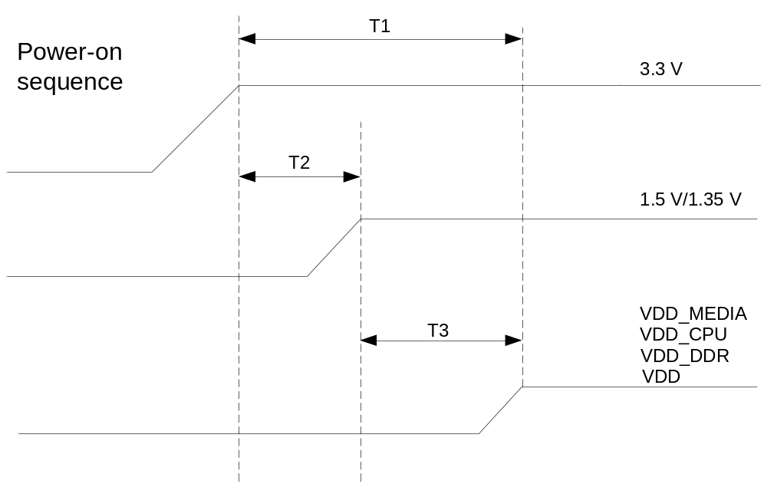
The following conditions must be met: 0 < T1 ≤ 100 ms, T2 > 0, T3 > 0.
When four core power supplies are powered on, the interval between the first core power and the last core power cannot be longer than 20 ms.

              - Power-off sequence
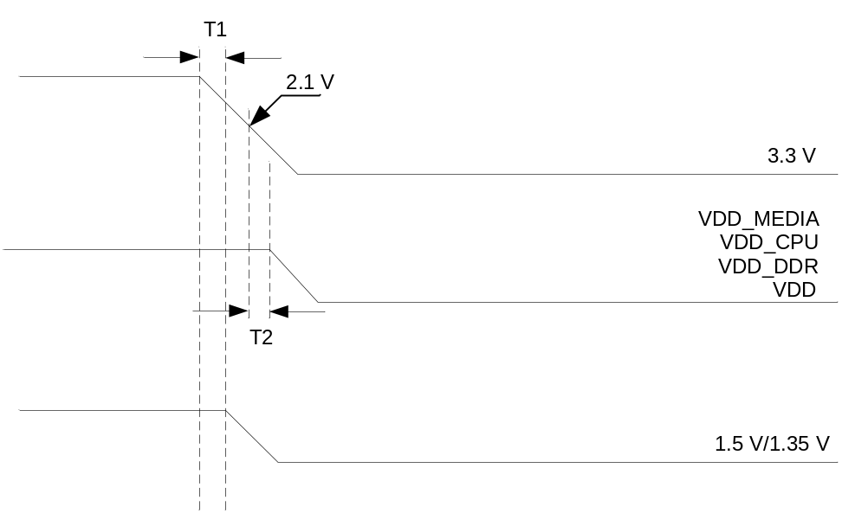
The following conditions must be met: T1 > 0, T2 > 0.

Design Requirements on the Clock Circuit of the Master Chip
√ | Items | Customer Confirmation (PASS/NO PASS) | Remarks
 | The Hi3516A needs a 24 MHz external working clock. The maximum deviation is 30 ppm. The clock signal traces must be surrounded by GND traces.

Design Requirements on the Reset Circuit
√ | Items | Customer Confirmation (PASS/NO PASS) | Remarks
 | The chip reset mode is selected by configuring the POR_SEL pin. The WDG_RSTN/SYS_RSTN_OUT pins must connect to the 4.7 kΩ pull-up resistor.
The POR_SEL level is low.
The internal power on reset (POR) circuit is enabled and it provides a reset signal to reset the entire chip during power-on. The WDG_RSTN/SYS_RSTN_OUT pin is multiplexed as the SYS_RSTN_OUT function. When the chip is reset or the WDG takes effect, this pin outputs a low level for 130 ms. SYS_RSTN_OUT and the internal reset signal are from the same source, and it can be used by flash memories or peripherals for reset.
The POR_SEL level is high.
The internal POR circuit is disabled and the chip reset depends on the status of the RSTN pin. The WDG_RSTN/SYS_RSTN_OUT pin is multiplexed as the WDG_RSTN function. When the WDG takes effect, this pin outputs low level continuously and is restored to high level until the RSTN pin detects a low level reset signal.
The WDG_RSTN/SYS_RSTN_OUT pin must not be connected to the RSTN pin directly.
 | It is recommended that the component with the reset function be selected as the boot flash memory. The boot flash memory must release the reset signal before the Hi3516A or they release the reset signals simultaneously.

Design Requirements on the Internal RTC
√ | Items | Customer Confirmation (PASS/NO PASS) | Remarks
 | The timing accuracy of the embedded real-time clock (RTC) is affected by the manufacturing accuracy and temperature offset of the external crystal oscillator. For details about correction schemes, see the RTC Correction Scheme Application Notes.
 | Ensure that the board is clean and avoid power leakage due to tin residue stitching. Otherwise the external crystal oscillator for the RTC does not work in high humidity environment.
 | If high timing accuracy is required, you are advised to select the external RTC with an embedded crystal oscillator or a crystal oscillator with the temperature compensation function.

Design Requirements on the DDR Circuit
√ | Items | Customer Confirmation (PASS/NO PASS) | Remarks
 | You are advised to connect the double-data rate (DDR) data signals DQS, DQ, and DM directly, because there is an internal on-die termination (ODT) resistor and therefore no external serial resistors are required. For details, see the Hi3516A Hardware Design User Guide.
 | You are advised to connect DDR clock signals to matched resistors at the terminal end. The Hi3516A requires that a 1% 100 Ω resistor be connected in series between DDR_CLK_N and DDR_CLK_P at the load end.
 | The reference power supplies of the DDRs are obtained by dividing the voltages of 1.5 V or 1.35 V power respectively. You are advised to use two 1% 1 kΩ (or smaller) voltage divider resistors in series to ensure optimum voltage.
 | Decoupling capacitors are connected close to power pins of the DDR, especially for the reference voltage part. This ensures that the DDR works properly.
 | You are advised to connect the DDR signals of address, reset, chip select (CS), and command to a 33 Ω resistor in series at the master chip end to ensure the signal quality. For details, see the schematic diagram of the Hi3516A demo board.

Design Requirements on the SPI/NAND Flash Circuit
√ | Items | Customer Confirmation (PASS/NO PASS) | Remarks
 | If a NAND flash is connected, the system can boot only from CS0. You are advised to connect 4.7 kΩ pull-up resistors to the RDY, CS, and write protection (WP) signals of the NAND flash.
 | If an SPI flash is connected, the system can boot from CS1. You are advised to connect 4.7 kΩ pull-up resistors to CS1 and HOLD signals and a 4.7 kΩ pull-down resistor to the WP signal.
 | For details about the reset signal of the flash memory from which the system boots, see 1.3 "Design Requirements on the Reset Circuit."

Design Requirements on the I²C Circuit
√ | Items | Customer Confirmation (PASS/NO PASS) | Remarks
 | Inter-integrated circuit (I²C) signals serial clock (SCL) and serial data (SDA) must be connected to external pull-up resistors, because the signal pins are OD outputs. The impedance depends on the bus load.1 kΩ pull-up resistors are recommended.
The Hi3516A has three groups of inter-integrated circuit (I²C) pins. I²C0 is used to configure the sensor and is multiplexed with SCLK and SDO of SPI0, and the interface level can be 1.8 V or 3.3 V.
I²C1 is used to connect to a peripheral and is multiplexed with SCLK and SDO of SPI1, and the interface level must be 3.3 V.
I²C2 is used to connect to a peripheral, and the interface level must be 3.3 V.
 | The addresses for the components on the I²C bus do not conflict with each other.

Design Requirements on the SPI Circuit
√ | Items | Customer Confirmation (PASS/NO PASS) | Remarks
The Hi3516A has two groups of serial peripheral interface (SPI) pins. SPI0 is used to configure the sensor, and the interface level can be 1.8 V or 3.3 V.
SPI1 is used to connect to a peripheral, and the interface level must be 3.3 V.

Design Requirements on the Video Circuit
√ | Items | Customer Confirmation (PASS/NO PASS) | Remarks
One complementary metal-oxide-semiconductor (CMOS) parallel video input (VI) interface (the pin name contains the VI field but not the MIPI field), one multi-mode VI interface (the pin name contains the MIPI field), and a group of independent interfaces for controlling sensors are supported. The multi-mode input interface is compatible with the differential data input of low-voltage differential signaling (LVDS), differential input of mobile industry processor interface (MIPI), and parallel input of CMOS.
The CMOS and multi-mode VI interfaces cannot be used at the same time.
CMOS parallel VI interface (the pin name contains the VI field but not the MIPI field):
The maximum bit width, maximum clock frequency, and maximum data signal frequency of the CMOS parallel VI interface are 16 bits, 148.5 MHz, and 74.25 MHz respectively.
The CMOS VI interface supports data in the formats of RAW, BT.1120, BT.656, and BT.601.
For the 16-bit sensor, the raw data pins are connected to D0−D15 pins of the VI interface in sequence.
For the 12-bit sensor, the raw data pins are connected to D4−D15 pins of the VI interface in sequence.
For data in the format of BT.656 or BT.601, the data signal pins connect to D0−D7 of the VI interface in sequence.
For data in the format of BT.1120, the data signal pins connect to the VI interface in sequence (the C signal connects to the lower eight bits and the Y signal connects to the upper eight bits).
The CMOS parallel VI interface level can be 1.8 V or 3.3 V. The levels of the connected power and signal must be the same.
The data signal frequency of the CMOS VI interface is very high. Ensure that the traces have the same length, and signal current return paths are provided during PCB routing. For details, see the description of PCB design in the Hi3516A Hardware Design User Guide.
Multi-mode VI interface (the pin name contains the MIPI field):
For details about the requirements on specifications and design when the multi-mode VI interface is used as the CMOS parallel VI interface, see "Requirements on the CMOS Parallel VI Interface."
When the multi-mode VI interface is used as the LVDS/MIPI differential VI interface, MIPI0 and MIPI1 each has a pair of differential CLK signals and four pairs of differential data signals, and the maximum interface frequency is 500 MHz.
For the sensor with only one pair of differential CLKs inputs, the MIPI0 CLK is required.
For the sensor with less than four pairs of differential CLKs inputs, consecutive pins starting from D0 are required.
The unused pins are floated.
The interface for controlling sensors contains the SENSOR_RSTN, SENSOR_CLK, and SPI0/I²C0 signals. DVDD3318_SENSOR is the power supply for these signals.
The SPI0 signal is multiplexed with the I²C0 signal.
When the signal is multiplexed as the I²C0 signal, two 1 kΩ pull-up resistors must be connected to I²C0_SCL and I²C0_SDA respectively.
When the signal is multiplexed as the SPI0 signal, a 4.7 kΩ pull-up resistor must be connected to SPI0_CSN.
The levels of the connected DVDD3318_SENSOR and the signal of the sensor must be the same.
One video output (VO) interface is supported:
The VO interface is compatible with BT.656 and BT.1120 VOs.
As the BT.1120 output, the maximum bit width, maximum clock frequency, and maximum data signal frequency of the VO interface are 16 bits, 148.5 MHz, and 74.25 MHz respectively.
The VO interface does not provide external row synchronization and field synchronization signals and supports only internal synchronization.
For a BT.1120 signal, the upper eight bits are the Y (luminance) signal, and the lower eight bits are the C (chrominance) signal. Ensure that the connection is correct.
 | AVDD33_VDAC is isolated from DVDD33 by using an EMI bead.
 | VDAC_IREF connects to an external 1% 1K Ω pull-down resistor.
 | There is only one digital-to-analog converter (DAC) video output. The VDAC_CVBS VO pin must connect to a 75 Ω pull-down resistor.

Design Requirements on the Audio Circuit
√ | Items | Customer Confirmation (PASS/NO PASS) | Remarks
 | The Hi3516A provides an analog audio CODEC and an inter-IC sound (I²S) interface. The I²S signals can output through three groups of pins. However, the audio CODEC and I²S interface cannot be used simultaneously.
 | An external 10 µF capacitor and a 100 nF capacitor are connected in parallel between AC_VREF of the audio CODEC and GND.
 | When the microphone (MIC) input is used, it is recommended that the chip divide a signal into two channels at the near end of the AC_MICBIAS output pin as the corresponding bias levels of the audio-left and audio-right channels, which ensures excellent audio quality. For details, see the latest schematic diagram of the Hi3516A demo board.
 | It is recommended that the DC blocking capacitor connected to AC_LINER and AC_LINEL be placed close to the Hi3516A. For details about the design of resistors and capacitors, see the latest schematic diagram of the Hi3516A peripheral board.
 | You are advised to connect an audio amplifier and filtering circuit to the audio output pins AC_OUTL and AC_OUTR, which ensures excellent audio quality. For details, see the latest schematic diagram of the Hi3516A peripheral board.
 | AC_OUTL and AC_OUTR must connect to an external 470 kΩ pull-down resistor close to the output interface to reduce POP tone during power-on and power-off.
 | MCLK of the I²S interface must connect to a 33 Ω resistor in series at the near end of the chip to ensure the signal quality.

Design Requirements on the USB Circuit
√ | Items | Customer Confirmation (PASS/NO PASS) | Remarks
 | It is recommended that the USB_REXT pin connect to a 1% 135 Ω pull-down resistor. Connect the resistor close to the Hi3516A.
 | The USB differential traces must not be routed across plane splits and the differential traces must be surrounded by GND traces. The impedance of each USB differential trace is 90 Ω±10%.

Design Requirements on the ETH Circuit
√ | Items | Customer Confirmation (PASS/NO PASS) | Remarks
 | It is recommended that the MDIO pin connect to a 4.7 kΩ pull-up resistor.
 | It is recommended that a 33 Ω resistor be connected to the MDCK signal in series close to the source end to ensure the signal quality.
 | It is recommended that the GPIO0_1/TEMPER_DQ (D20) pin be multiplexed as the GPIO function and be connected to the reset control pin of the network PHY as the reset control signal of the network PHY. The signal is active low.
 | The I/O level of the Hi3516A Ethernet MAC can be 1.8 V, 2.5 V, and 3.3 V.
 | If the 3.3 V, 2.5 V, or 1.8 V power is used for the Ethernet PHY communication, ensure that the level supported by the Ethernet PHY, pull-up and pull-down of the SELRGV pin of the Ethernet PHY, and the I/O power supply of the Ethernet PHY and DVDDIO_RGMII of the Hi3516A are correct and consistent.
 | The MAC interface of the Hi3516A supports the reduced gigabit media-independent interface (RGMII), reduced media-independent interface (RMII), and media-independent interface (MII) modes. In MII mode, for pins related to the Ethernet PHY side, CRS, COL, and RXER pins are floated and the TXER pin is pulled down. The connection mode of other signals remains unchanged.
 | The connection mode of the transformer central tap varies according to ETH PHY vendor. Connect the transformer central tap by following the application notes and reference design documents provided by ETH PHY vendors.

Design Requirements on JTAG and System Control Circuits
√ | Items | Customer Confirmation (PASS/NO PASS) | Remarks
 | 4.7 kΩ pull-up resistors are connected to TDI, TDO, and TMS pins of the JTAG interface; a 1 kΩ pull-down resistor is connected to the TCK pin; a 10 kΩ pull-down resistor is connected to the TRST pin and a pull-up resistor is reserved. If the JTAG function is not used, multiplex it as a GPIO pin by changing the pull-up/pull-down status of the JTAG_EN pin.
 | The TESTMODE pin connects to a 10 kΩ pull-down resistor.

Design Requirements on the SD Card Circuit
√ | Items | Customer Confirmation (PASS/NO PASS) | Remarks
 | Power on or power off the power supply of the secure digital (SD) card by using the MOSFET. The control signal is active high.
When the board needs to support the secure digital extended capacity (SDXC) card, the DVDD18_SDIO pin must connect to a 1.8 V power.
When the board needs to support only the secure digital high capacity (SDHC) card, the DVDD18_SDIO pin can be floated.
The DATA and CMD signals of SDIO must connect to pull-up resistors and then connect to the SDIO_VOUT when the board needs to support the SDXC card. The 10 kΩ pull-up resistors are recommended.
The DATA and CMD signals of SDIO can connect to pull-up resistors and then connect to the SDIO_VOUT or 3.3 V power when the board needs to support only the SDHC card. The 10 kΩ pull-up resistors are recommended.
 | The DETECT signal of SDIO must connect to the DETECT pin of the SD card and also connect to a pull-up resistor and then to the 3.3 V power. The 10 kΩ pull-up resistor is recommended and the resistor must not be floated.
 | The components that consume much power must not be placed on the back side of the SD card during PCB layout. This prevents the SD card from being damaged at high temperatures.
 | When the SDXC interface of the Hi3516A functions as the GPIO interface, for details about the usage method, see the content related to the GPIO interface in the Hi3516A/Hi3516D Professional HD IP Camera SoC Data Sheet.

Design Requirements on the UART Circuit
√ | Items | Customer Confirmation (PASS/NO PASS) | Remarks
 | The debugging serial port must be led out. UART 0 is used for debugging by default.

Design Requirements on AVDD_EFUSE
√ | Items | Customer Confirmation (PASS/NO PASS) | Remarks
 | AVDD_EFUSE must connect to GND directly.

